1.

function numberToWords(number) {

if (number < 1 || number > 999) {

return "Number out of range!";

}

const ones = ["", "One", "Two", "Three", "Four", "Five", "Six", "Seven", "Eight", "Nine"];

const teens = ["Ten", "Eleven", "Twelve", "Thirteen", "Fourteen", "Fifteen", "Sixteen", "Seventeen", "Eighteen", "Nineteen"];

const tens = ["", "", "Twenty", "Thirty", "Forty", "Fifty", "Sixty", "Seventy", "Eighty", "Ninety"];

let words = "";

if (number >= 100) {

let hundredPlace = (number / 100) | 0;

if (hundredPlace === 1) {

words += "One Hundred ";

} else if (hundredPlace === 2) {

words += "Two Hundred ";

} else if (hundredPlace === 3) {

words += "Three Hundred ";

} else if (hundredPlace === 4) {

words += "Four Hundred ";

} else if (hundredPlace === 5) {

words += "Five Hundred ";

} else if (hundredPlace === 6) {

words += "Six Hundred ";

} else if (hundredPlace === 7) {

words += "Seven Hundred ";

} else if (hundredPlace === 8) {

words += "Eight Hundred ";

} else if (hundredPlace === 9) {

words += "Nine Hundred ";

}

number %= 100;

}

if (number >= 20) {

let tensPlace = (number / 10) | 0;

if (tensPlace === 2) {

words += "Twenty ";

} else if (tensPlace === 3) {

words += "Thirty ";

} else if (tensPlace === 4) {

words += "Forty ";

} else if (tensPlace === 5) {

words += "Fifty ";

} else if (tensPlace === 6) {

words += "Sixty ";

} else if (tensPlace === 7) {

words += "Seventy ";

} else if (tensPlace === 8) {

words += "Eighty ";

} else if (tensPlace === 9) {

words += "Ninety ";

}

number %= 10;

}

// Handling the teens (10-19)

if (number >= 10 && number < 20) {

if (number === 10) {

words += "Ten ";

} else if (number === 11) {

words += "Eleven ";

} else if (number === 12) {

words += "Twelve ";

} else if (number === 13) {

words += "Thirteen ";

} else if (number === 14) {

words += "Fourteen ";

} else if (number === 15) {

words += "Fifteen ";

} else if (number === 16) {

words += "Sixteen ";

} else if (number === 17) {

words += "Seventeen ";

} else if (number === 18) {

words += "Eighteen ";

} else if (number === 19) {

words += "Nineteen ";

}

number = 0;

}

if (number > 0) {

if (number === 1) {

words += "One ";

} else if (number === 2) {

words += "Two ";

} else if (number === 3) {

words += "Three ";

} else if (number === 4) {

words += "Four ";

} else if (number === 5) {

words += "Five ";

} else if (number === 6) {

words += "Six ";

} else if (number === 7) {

words += "Seven ";

} else if (number === 8) {

words += "Eight ";

} else if (number === 9) {

words += "Nine ";

}

}

return words; // No trim here

}

// Example usage

let number = 789;

console.log(numberToWords(number));

2.

3.

4.

1.

2.

5.

let record = [

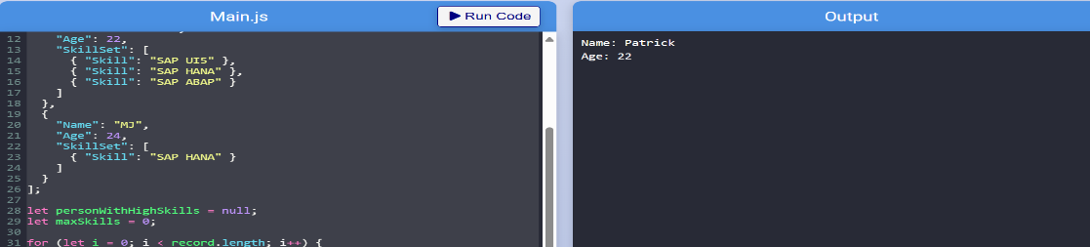 {

"Name": "Gibo",

"Age": 16,

"SkillSet": [

{ "Skill": "SAP UI5" },

{ "Skill": "SAP HANA" }

]

},

{

"Name": "Patrick",

"Age": 22,

"SkillSet": [

{ "Skill": "SAP UI5" },

{ "Skill": "SAP HANA" },

{ "Skill": "SAP ABAP" }

]

},

{

"Name": "MJ",

"Age": 24,

"SkillSet": [

{ "Skill": "SAP HANA" }

]

}

];

let personWithHighSkills = null;

let maxSkills = 0;

for (let i = 0; i < record.length; i++) {

let person = record[i];

let skillCount = person.SkillSet.length;

if (skillCount > maxSkills) {

maxSkills = skillCount;

personWithHighSkills = person;

}

}

console.log("Name: " + personWithHighSkills.Name);

console.log("Age: " + personWithHighSkills.Age);